Detecting SQL Injection Attacks Using Machine Learning or Transformer Models

Chapter 1: Introduction
1.1 Background to the Study
Structured Query Language Injection (SQL injection or SQLi) continues to be a common attack vector in online application security, as it capitalises on the interface between user-controlled input and database query execution. Improper validation, parameterisation, or sanitisation of input may enable an attacker to alter the intended structure of a query, resulting in unauthorised data access, bypassing of authentication processes, alteration of records, or disruption of database availability, as shown in figure 1.2. SQL injection is not only a programming flaw; it constitutes an application-layer security breach with immediate consequences for confidentiality, integrity, and availability.

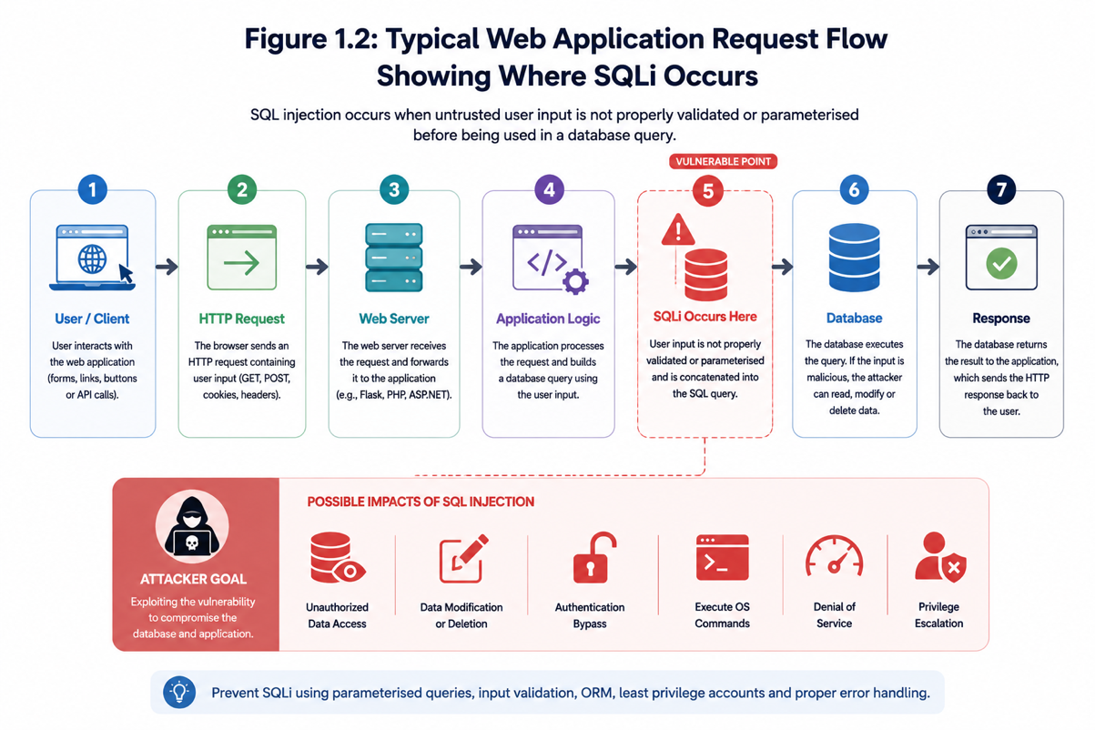
Figure 1.1: Typical web application request flow showing where SQLi occurs

The rate of SQL injection is shown in industry and standards-based reports. OWASP continuously categorises injection-related vulnerabilities as some of the most critical dangers to online applications, indicating that inadequate input handling persists widely in practice (OWASP, 2021).
Although traditional methods like prepared statements, stored procedures, input validation, and Object-Relational Mapping (ORM) frameworks are crucial, they do not entirely eliminate the necessity for runtime detection. In production systems, old code, misconfigurations, third-party integrations, and inconsistent validation processes may still reveal exploitable vulnerabilities.

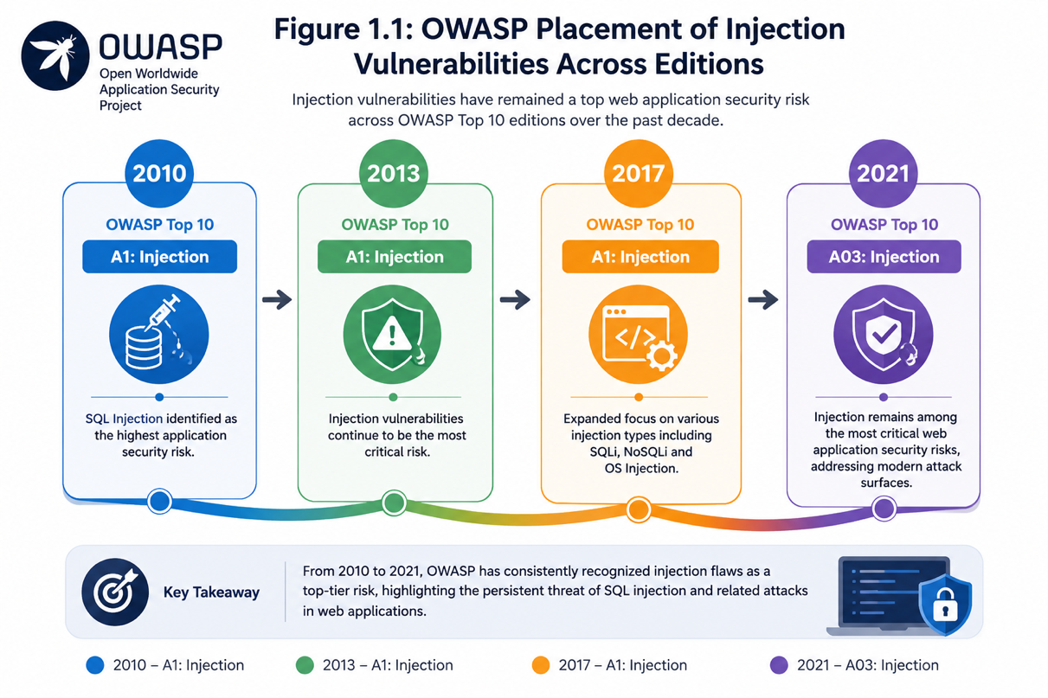
Figure 1.2: OWASP placement of injection vulnerabilities across editions
In this context, machine learning has emerged as a promising supplement for SQL injection detection. Instead of solely depending on written signatures, machine learning models can identify lexical, structural, and semantic patterns that differentiate benign database queries from malicious inputs. Recent research indicates that these models can attain high detection accuracy when complemented by careful preprocessing, feature extraction, and appropriate datasets (Rosca, Stancu and Popescu, 2025). Nonetheless, questions exist concerning generalisation, interpretation, practical implementation, and adaptability to changing attack patterns.
This dissertation examines the efficacy of machine learning models and conceptual transformer-based methodologies to improve SQL injection detection as a supplementary security measure in web applications. The research emphasises both offline classification accuracy and runtime integration using a Flask middleware architecture that can analyse API requests prior to query execution.
1.2 Problem Statement
Despite significant advancements in SQL injection detection research, numerous published studies continue to focus on offline assessment under controlled dataset environments. Although high accuracy levels are often claimed, these outcomes do not inherently indicate that the model can function effectively in a real-world application setting. Moreover, several current research studies poorly address deployment-related factors such as false positives in typical user traffic, transparency of runtime decisions, reproducibility of feature pipelines, and practical integration of middleware.

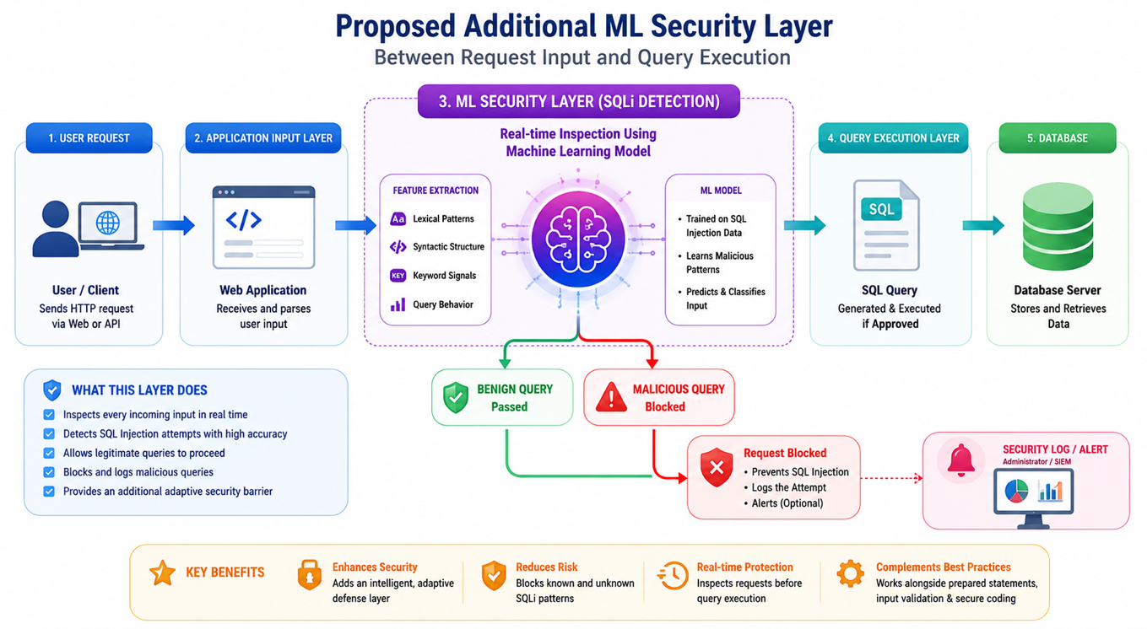
Figure 1.3: Proposed additional ML security layer between request input and query execution

A secondary issue related to the variety of SQL injection patterns. SQL injection payloads do not adhere to a singular template. They may manifest as union-based, error-based, boolean-based, time-based, stacked-query, or comment-based attacks, usually using syntactic obfuscation. Signature-based or rule-based systems may encounter difficulties in adapting when an assault deviates from established patterns (Demilie and Deriba, 2022). This necessitates adaptive detection methodologies that can learn from data while maintaining interpretability and operational usability.

Attack Type | Description | Typical Technique | Consequences
Union-Based SQL Injection | Exploits the SQL UNION operator to combine malicious queries with legitimate ones. | Injecting UNION SELECT statements to extract data from other tables. | unauthorised data disclosure (e.g., user credentials, sensitive records).
Error-Based SQL Injection | Forces the database to generate error messages that reveal information about its structure. | Injecting malformed queries that trigger database errors. | Database schema exposure, aiding further attacks.
Boolean-Based Blind SQL Injection | Infers data by observing differences in application response (true/false conditions). | Injecting conditional statements like AND 1=1 or AND 1=2. | Slow data extraction without direct output visibility.
Time-Based Blind SQL Injection | Determines query success based on delayed server responses. | Using functions like SLEEP or WAITFOR DELAY. | Data extraction through timing analysis; performance degradation.
Stacked Queries SQL Injection | Executes multiple SQL statements in a single query. | Using semicolons to append malicious queries (e.g., ; DROP TABLE users). | Data manipulation, deletion, or full database compromise.
In-Band SQL Injection | Uses the same communication channel for injection and data retrieval. | Union-based or error-based techniques. | Fast data exfiltration if successful; high severity breach.
Inferential (Blind) SQL Injection | Relies on indirect responses rather than direct data output. | Boolean-based and time-based techniques. | Slow but stealthy data leakage over time.
Second-Order SQL Injection | Malicious input is stored and later executed in a different context. | Stored payloads executed when data is reused in queries. | Delayed exploitation leading to deep system compromise.
Out-of-Band SQL Injection | Uses external channels to retrieve data (rare). | DNS or HTTP requests triggered by database functions. | Data exfiltration bypassing normal detection mechanisms.
Table 1.1: Summary of common SQL injection attack types and consequences

A third issue is concerns methodology. The dissertation title expressly features "Transformer Models," however a significant portion of the existing SQLi literature remains focused on traditional machine learning, convolutional neural networks, long short-term memory networks, gated recurrent units, and ensemble techniques. Emerging lightweight attention-based and transformer-like methods are being documented in the literature; nonetheless, this domain is still poorly developed compared to traditional feature-based classifiers (Lo, Hwang and Tai, 2025). Thus, it is essential to identify current machine learning outcomes while explaining how transformer-based methodologies might advance the domain.

1.3 Aim of the Study
This study aims to evaluate the effectiveness of machine learning methodologies for detecting SQL injection attacks and to determine their suitability for integration as an additional layer of security in a web application environment.
1.4 Research Objectives
The study is guided by the following objectives:
- To analyse the nature of SQL injection attacks and the limitations of conventional prevention and detection methods.
- To prepare and preprocess SQL query data for machine learning-based detection.
- To develop and assess several classification models for identifying between benign and malicious SQL queries.
- To evaluate the efficacy of classical machine learning and deep learning sequence models within the same experimental framework.
- To implement the optimal model within a Flask middleware framework and analyse its performance under both benign and malicious API queries.
- To discuss how transformer-based methodologies could enhance or advance the existing status of SQL injection detection in future research.

1.5 Research Questions
The dissertation addresses the following research questions:
- Which features of SQL queries are most effective in distinguishing between benign and malicious behaviour?
- What is the effectiveness of classical machine learning and sequence-based deep learning models in detecting SQL injection attacks?
- What is the impact of training sample size on model performance and feature-space stability?
- Is it possible to integrate the chosen model into a web application middleware layer for real-time detection?
- What are the probable benefits of transformer-based methodologies in comparison to the models implemented in this study?

1.6 Significance of the Study
This research is important in three respects. First, it enhances the SQLi research by comparing various model families within a unified preprocessing and assessment framework. Secondly, it moves beyond benchmark-level testing by integrating the selected model into a middleware layer, thus tackling practical deployment viability. Third, it establishes a solid machine learning baseline against which transformer-based models can then be assessed more thoroughly.
The study is especially useful to organisations that maintain API-driven systems where user input is dynamically processed prior to database access. In such setting, a supplementary Machine Learning based inspection layer may offer enhanced protection when the present preventative techniques are inadequate.

Research Objectives | Research Questions
To examine the nature of SQL injection attacks and limitations of traditional prevention and detection techniques. | Which features of SQL queries are most useful for distinguishing benign from malicious behaviour?
To prepare and preprocess SQL query data suitable for machine learning-based detection. | How does training sample size influence model performance and feature-space stability?
To design and evaluate several classification models for SQL injection detection. | How effectively do classical ML and sequence-based deep learning models detect SQL injection attacks?
To compare classical machine learning and deep learning models within a unified pipeline. | How effectively do classical ML and sequence-based deep learning models detect SQL injection attacks?
To deploy the selected best-performing model within a Flask middleware architecture for runtime detection. | Can the selected model be integrated into a web application middleware layer for runtime detection?
To discuss how transformer-based approaches may extend SQLi detection in future research. | What are the likely advantages of transformer-based approaches compared with the models implemented in this study?
Table 1.2: Research objectives mapped to research questions
1.7 Scope of the Study
This dissertation examines SQL injection detection at the application input level. The system functions using SQL query strings or SQL-like request data extracted from API traffic. The study does not seek to replace secure development methods like parameterised queries or prepared statements. The proposed system serves as an auxiliary detecting layer.
The practical implementation uses the RbSQLi dataset to evaluate several classical and deep learning models, including Random Forest, Gradient Boosting, Logistic Regression, Decision Tree, SVM, KNN, Naive Bayes, DNN, LSTM, and GRU. Transformer models are examined conceptually and comparatively in the literature, although they are not the implemented architecture in the current deployment..
1.8 Dissertation Structure
The remainder of the dissertation is organised as follows:
- Chapter 2 examines the literature on SQL injection, conventional mitigation strategies, machine learning detection methods, deep learning, explainability, and transformer-based approaches.
- Chapter 3 highlights the methodology, including dataset preparation, preprocessing, model building, assessment design, and middleware deployment.
- Chapter 4 presents and analyses the experimental and runtime outcomes.
- Chapter 5 concludes the dissertation, outlines limitations, and suggests possibilities for future research.

